# Testing document

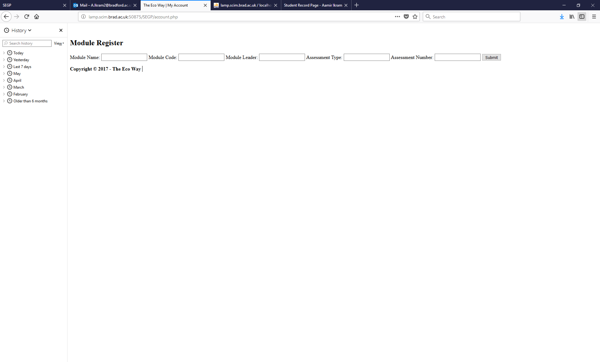

This is the first section that I will be talking about in the testing document. This website is shown once the account.php page is added to the URL. It will ask for all the information that the client will need to input correctly and will be added to the database.

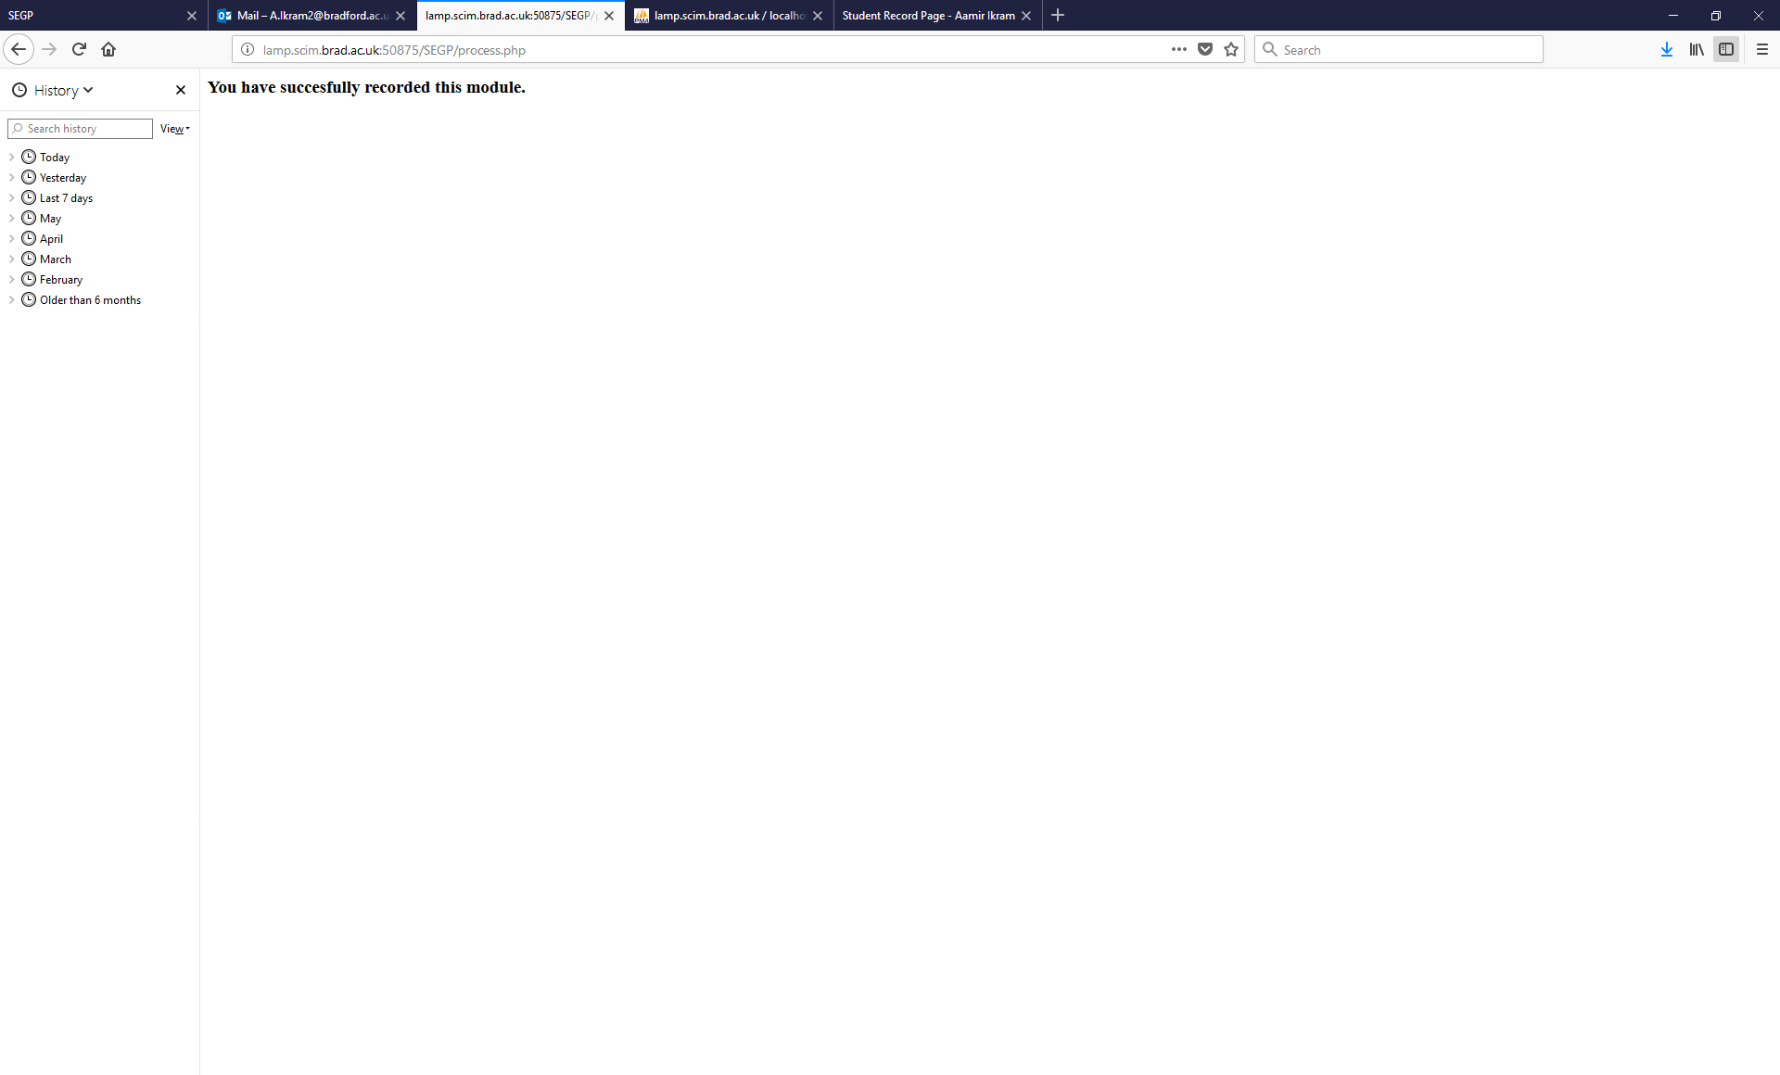

Once the correct information is added to the system it will be transferred to a different page showing the following statement which is ‘you have successfully recorded this module.

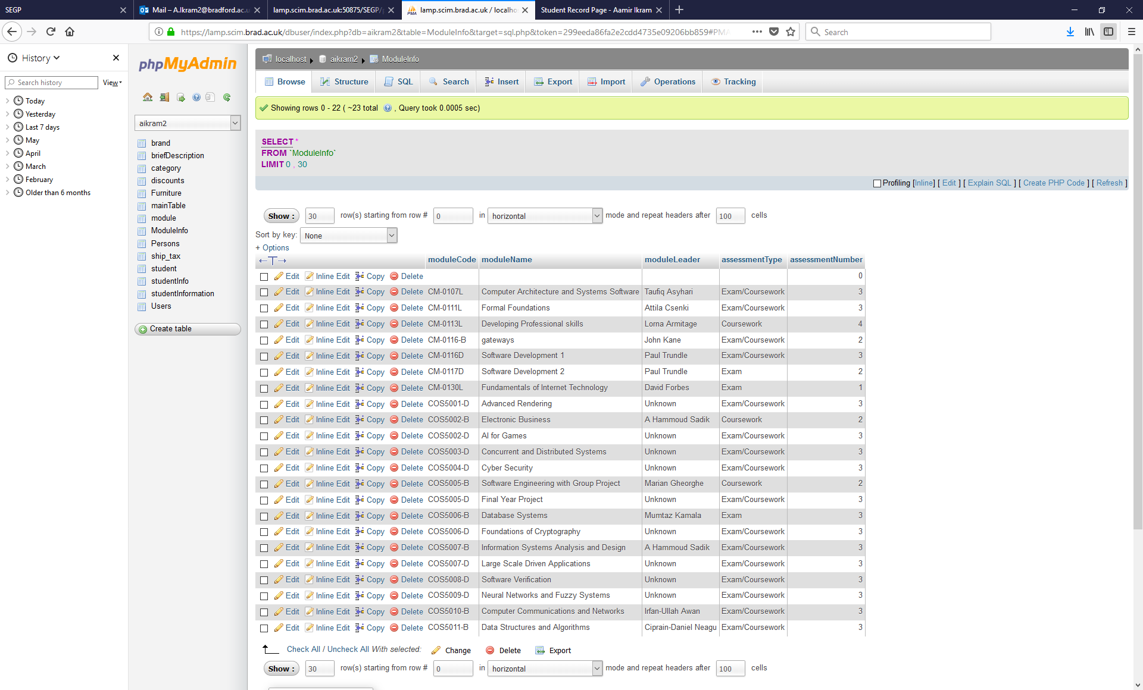

This is what the table is going to look like once all of the data about the modules has been added.

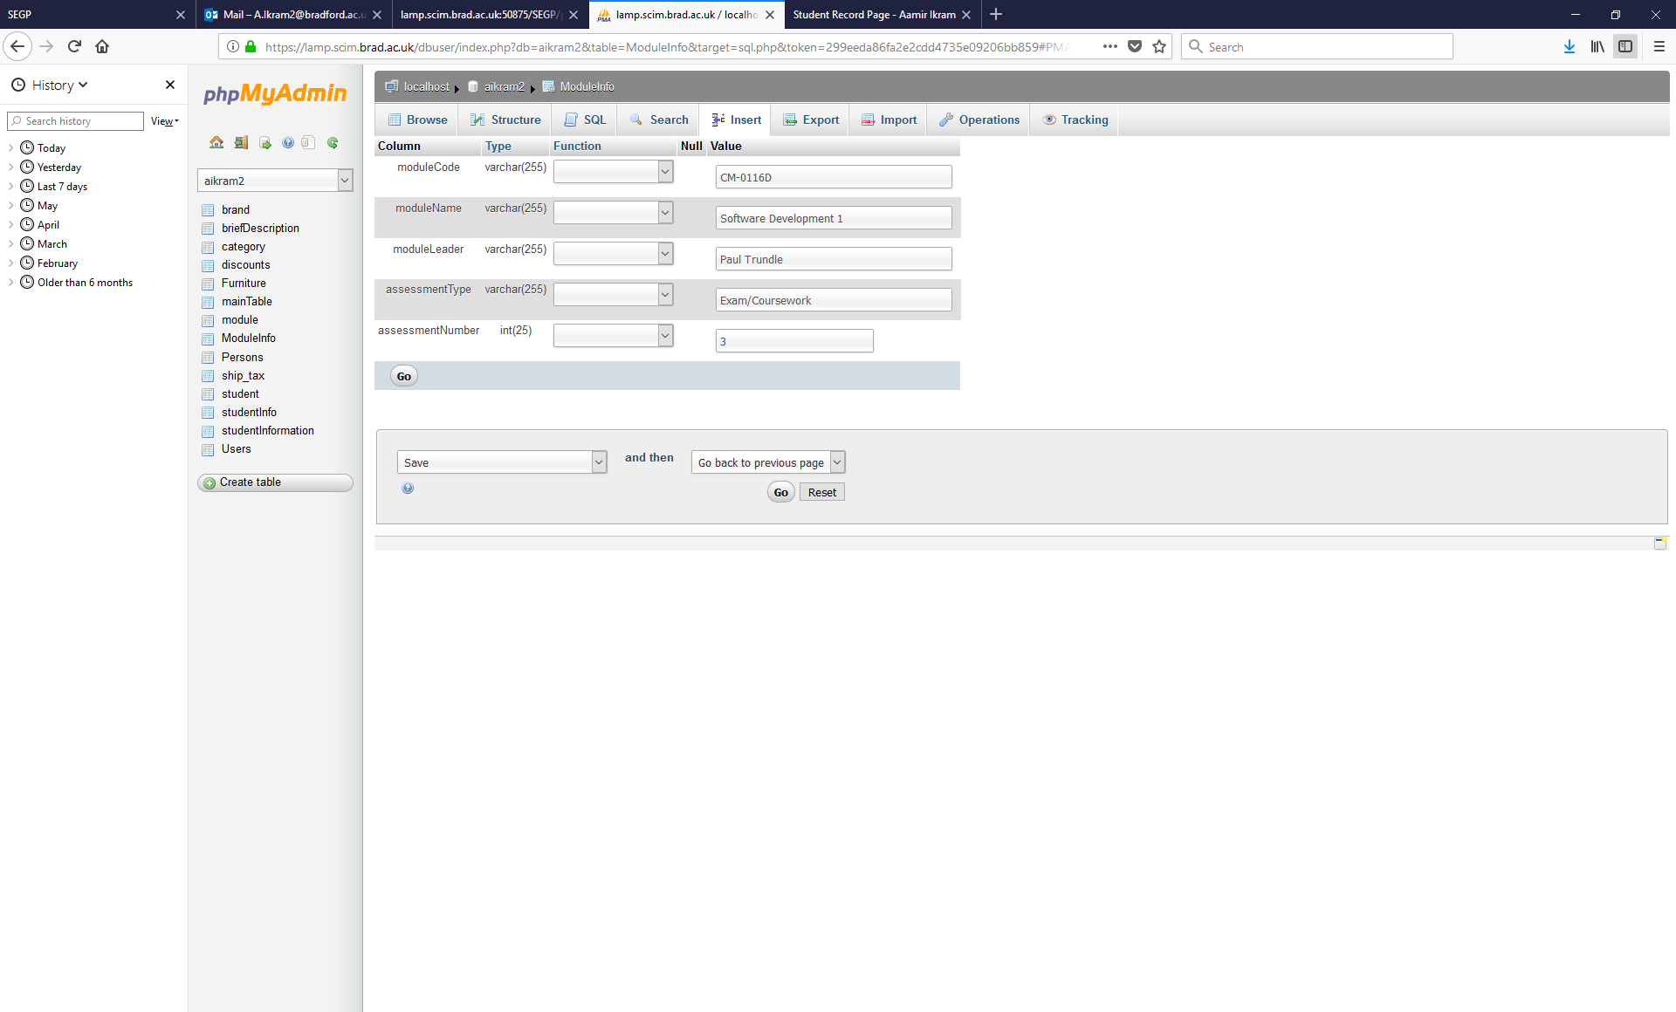

From here, the client will be able to edit any part of the database information by selecting edit and changing whatever needs to be changes.

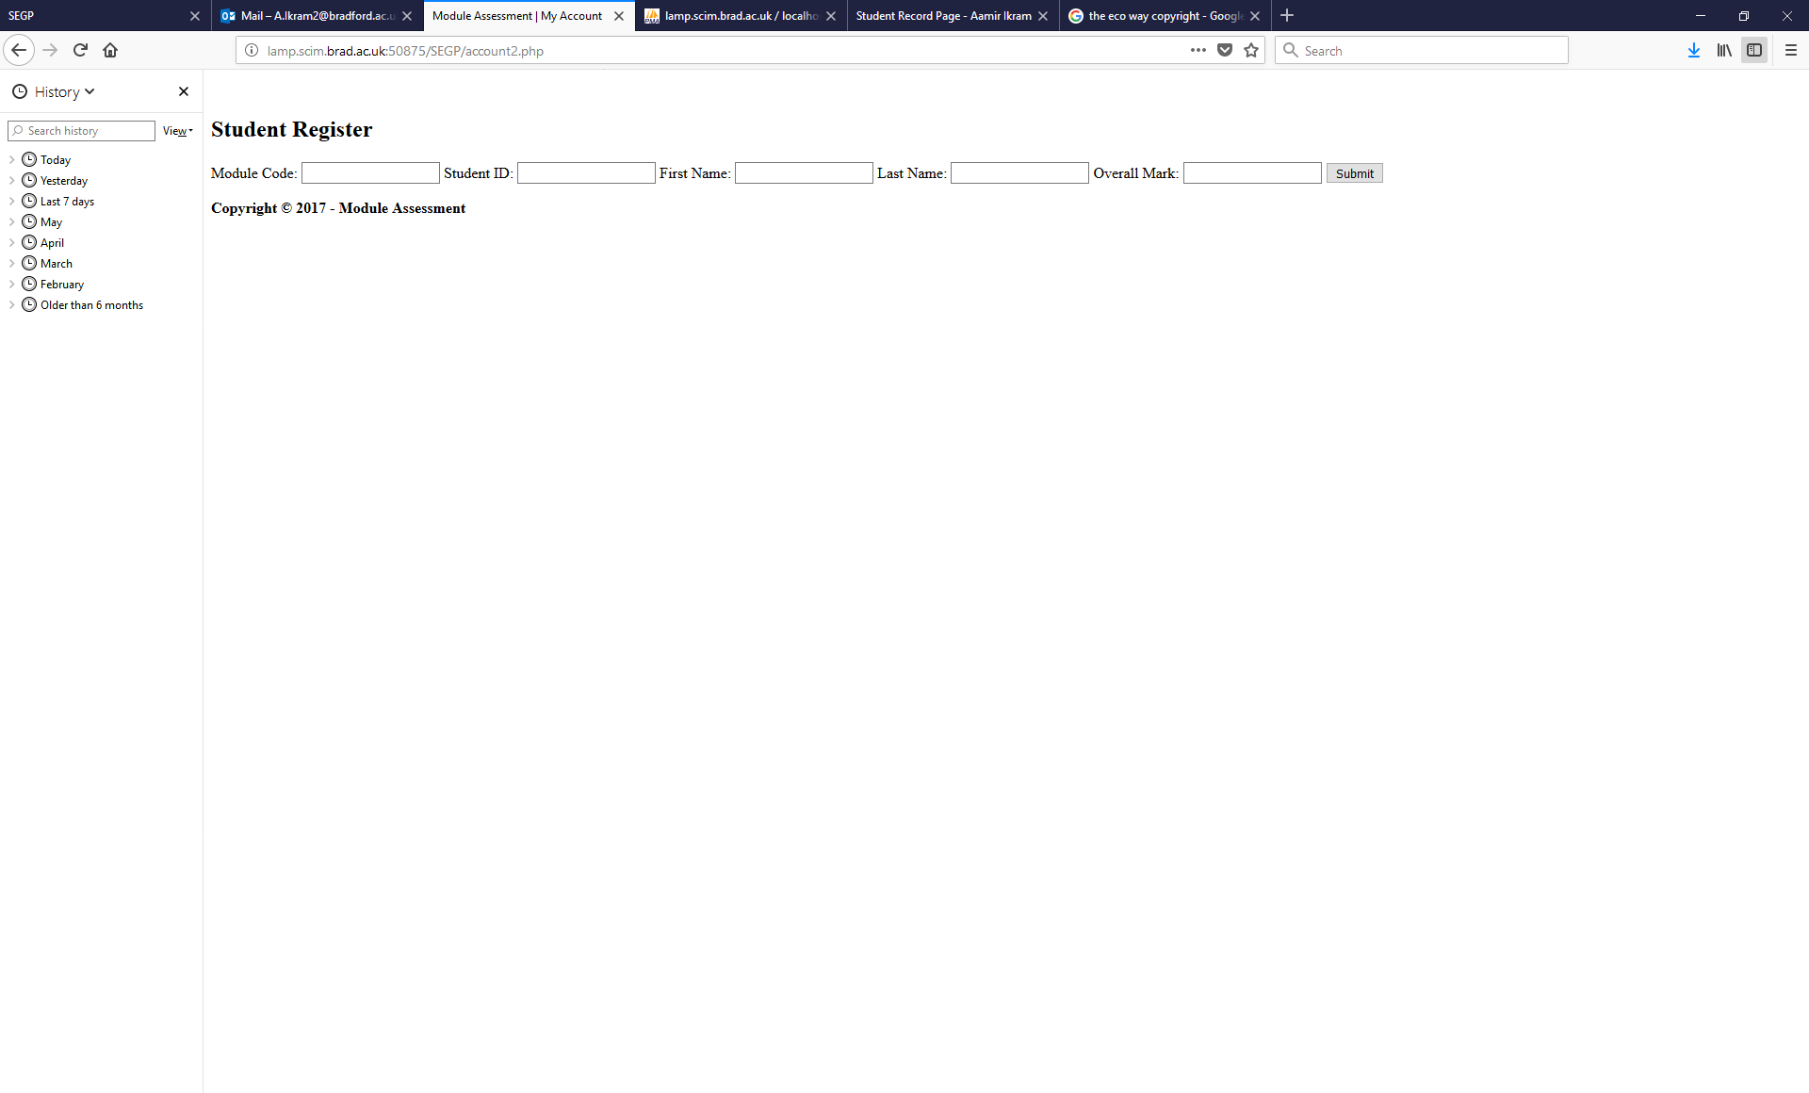

Next, we have the student register and it will be used the exact same way as the module register. This means that once the information has been added and clicked submit it will take you to the process2.php page, which will give an output of you, have successfully recorded this student. Them he client will be able to see all of the information on the database and will be able to edit on the myphpadmin.